

Enterprise Strategy Group | Getting to the bigger truth.™

AI Challenges:

First Look
NVIDIA DGX A100 System for AI: Accelerating Time to Insight
Date: April 2022 Author: Tony Palmer, Principal Validation Analyst

The percentage of organizations that currently have AI project solutions in production, pilot, or proof-of-concept (POC) phase with specialized infrastructure. | The percentage that report that they need 11 days or more to go from a trained model to production within their organization.
Artificial intelligence (AI) is ubiquitous, and the market is growing fast. Organizations need to find smarter and faster ways to gain value from their data. This is especially challenging considering that 36% of organizations report a problematic shortage of existing artificial intelligence and machine learning skills in their IT organization.
NVIDIA DGX A100 System for AI
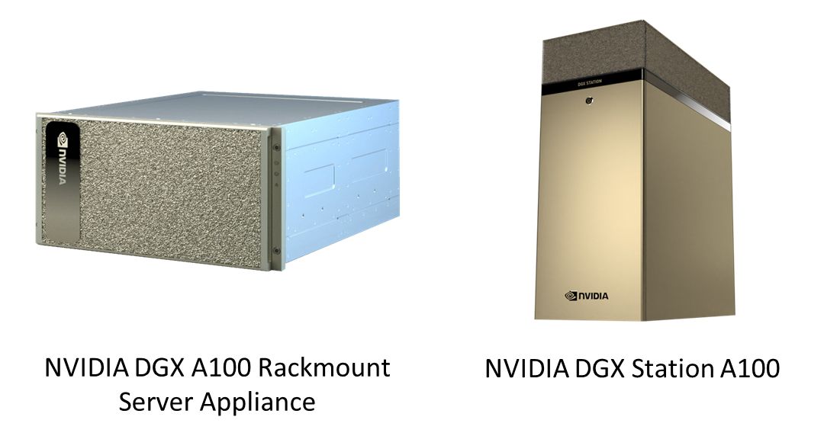
ESG evaluated the NVIDIA DGX A100 System for AI with a focus on how the platform reduces time to insight. NVIDIA DGX is a purpose-built AI platform designed to support analytics, AI, training, and inference. NVIDIA DGX is a tightly integrated platform with AI-optimized GPUs, architected end to end for AI. The NVIDIA DGX A100 system features eight NVIDIA GPUs and two 2nd Gen AMD EPYC processors. NVIDIA and Dell Technologies worked together to design and build a highly performant, best-of-breed architecture that can leverage the Dell EMC PowerScale storage portfolio. Organizations of all sizes can deploy this scalable data center technology anywhere it is needed in a rackmount server appliance or tower configuration. NVIDIA DGX is designed to enable the full AI lifecycle from AI platform launch to model creation to optimization, and to deliver immediate productivity while saving time, effort, and money. NVIDIA DGX offers rapid deployment and out-of-the-box productivity, combining specialized hardware with embedded tools and AI software, enabling organizations to extract value and insight from their data without the effort of software engineering, systems integration, or troubleshooting. This enables organizations to run experiments in hours instead of weeks, with performance that scales predictably.
In addition, the DGX A100 can support a large team of data science users using the multi-Instance GPU capability in each of the eight A100 GPUs inside the DGX system. Users can be assigned resources across as many as 56 virtual GPU instances, each fully isolated with their own high-bandwidth memory, cache, and compute cores. This allows administrators to right-size GPUs with guaranteed quality of service (QoS) for multiple workloads.

ESG First Look Highlights

ESG analysis of the NVIDIA DGX A100 System for AI reveals that:
- Organizations of all sizes and skill levels can benefit from the massively scalable NVIDIA DGX system to rapidly deliver deep data insight in the data center or at remote and branch locations.
- Organizations can leverage NVIDIA optimized frameworks, deploy on-premises, and manage in the cloud, all while providing massive performance scalability for fast iteration.
- Dell and NVIDIA technologies provide the foundation for successful AI solutions, which drive the development of advanced deep learning software frameworks, deliver massively parallel compute through NVIDIA GPUs and scale-out file systems to support the concurrency, performance, and capacity requirements of unstructured data sets.
- In deep learning training, the DGX A100 640GB achieved more than four times the training performance of the prior generation system.
- Using a big data analytics benchmark, the DGX A100 achieved 83X the performance of a CPU server driving 30 analytical retail queries, extract, transform, and load (ETL), machine learning (ML), and natural language processing (NLP) workloads on a 10TB dataset.
- Using the Multi-Instance GPU capability in the A100 GPU, users can assign resources that are right-sized for specific workloads on all 8 GPUs in a DGX A100 system.
- NVIDIA Professional Services (NVPS) provides consultative help—from initial strategy conception to data architecture, and from model development and MLOps to post-deployment support.

First Impressions
Organizations are struggling to leverage AI/ML to gain value from their data faster and more accurately. Only 1% of organizations surveyed by ESG claim they are able to go from a trained model to a production AI app in 10 days or less. What is needed is a solution that can deliver a streamlined, optimized software stack on an AI-optimized hardware platform that can flexibly and granularly allocate resources to workloads as needed.
ESG validated that the NVIDIA DGX A100 System for AI can accelerate an organization’s time to insight. The purpose-built AI platform from NVIDIA and Dell Technologies offers not just performance and scalability, but productivity-enhancing software and dedicated professional services support. For those looking to simplify and accelerate their AI journey, ESG recommends a serious look at the NVIDIA DGX A100.





All product names, logos, brands, and trademarks are the property of their respective owners. Information contained in this publication has been obtained by sources TechTarget, Inc. considers to be reliable but is not warranted by TechTarget, Inc. This publication may contain opinions of TechTarget, Inc., which are subject to change. This publication may include forecasts, projections, and other predictive statements that represent TechTarget, Inc.’s assumptions and expectations in light of currently available information. These forecasts are based on industry trends and involve variables and uncertainties. Consequently, TechTarget, Inc. makes no warranty as to the accuracy of specific forecasts, projections or predictive statements contained herein.
www.esg-global.com
contact@esg-global.com
508.482.0188
© 2022 TechTarget, Inc. All Rights Reserved.

This publication is copyrighted by TechTarget, Inc. Any reproduction or redistribution of this publication, in whole or in part, whether in hard-copy format, electronically, or otherwise to persons not authorized to receive it, without the express consent of TechTarget, Inc., is in violation of U.S. copyright law and will be subject to an action for civil damages and, if applicable, criminal prosecution. Should you have any questions, please contact Client Relations at cr@esg-global.com.
.

Source: ESG Survey Results, Supporting AI/ML Initiatives with a Modern Infrastructure Stack, May, 2021.
Source: ESG Research Report, 2022 Technology Spending Intentions Survey, November 2021.

